**MODULE 3: ACTIVITY 5: DATA ACCESS**

**IFT 544 MIDDLEWARE PROGRAMMING AND DATABSE SECURITY**

**AMBUK REHANI**

**Instructor: Prof. Dinesh Sthapit**

**09/24/2023**

REUSABLE COMPONENTS TO CREATE COMPOSITE COMPONENTS:

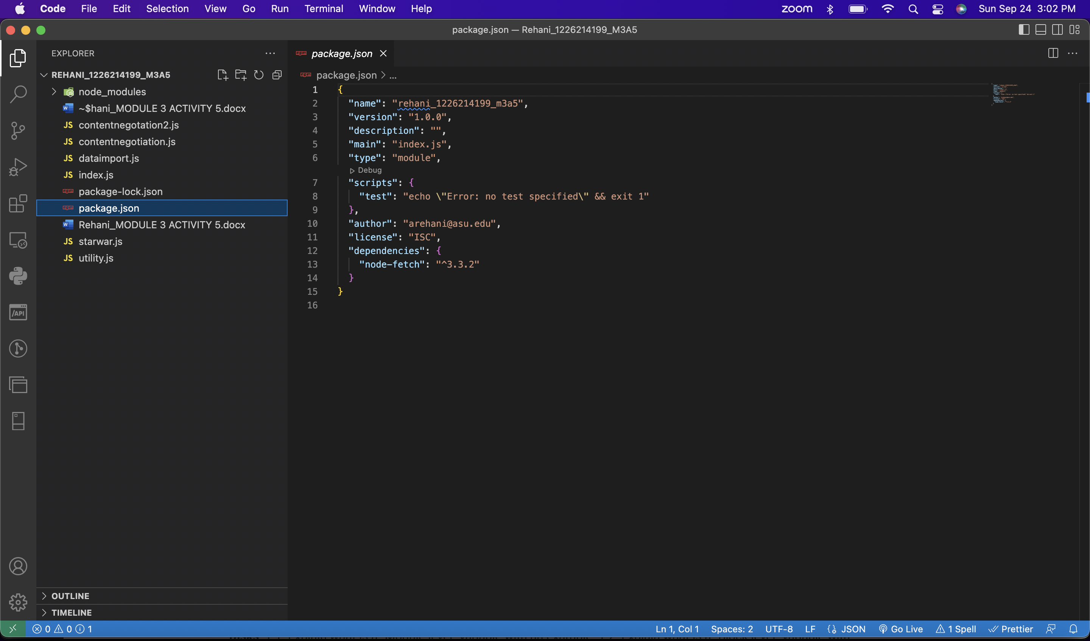

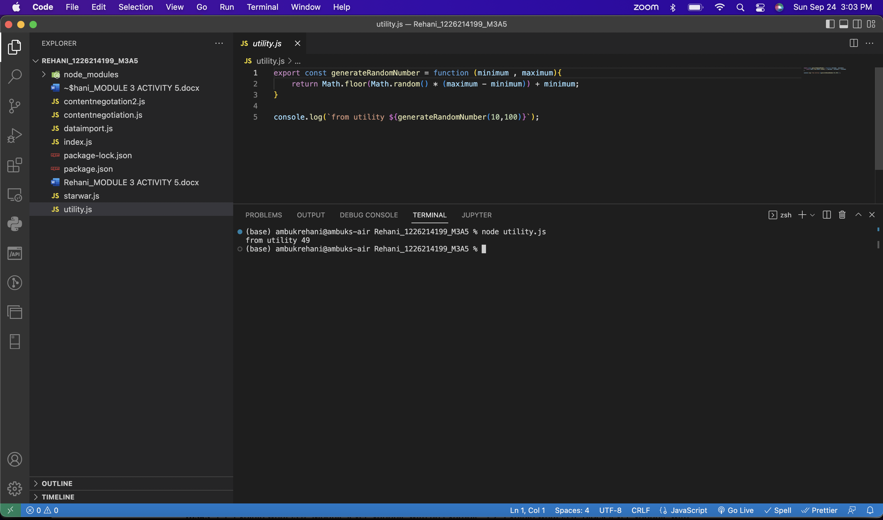

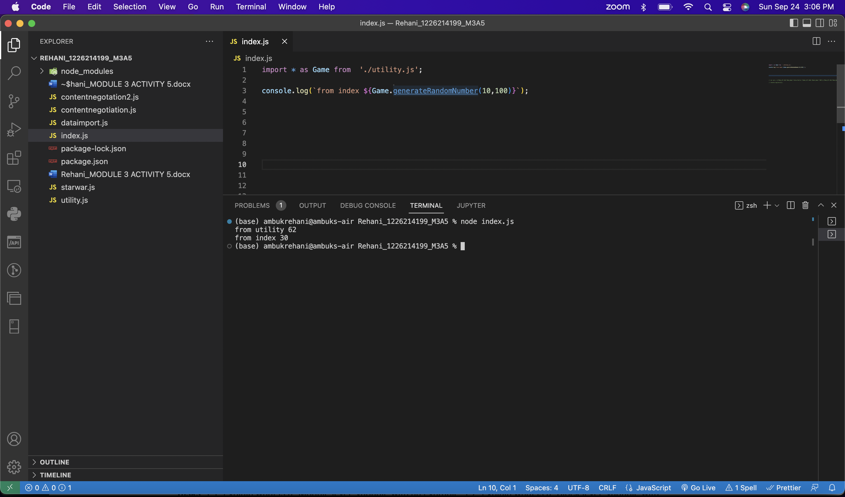

USING IMPORTING EXTERNAL MODULES:

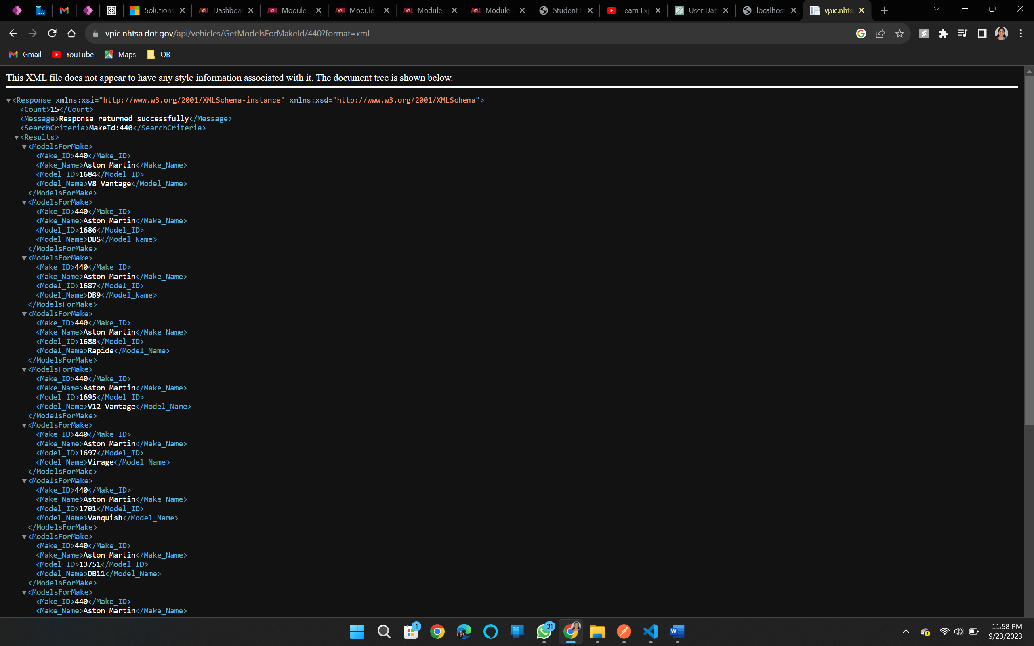

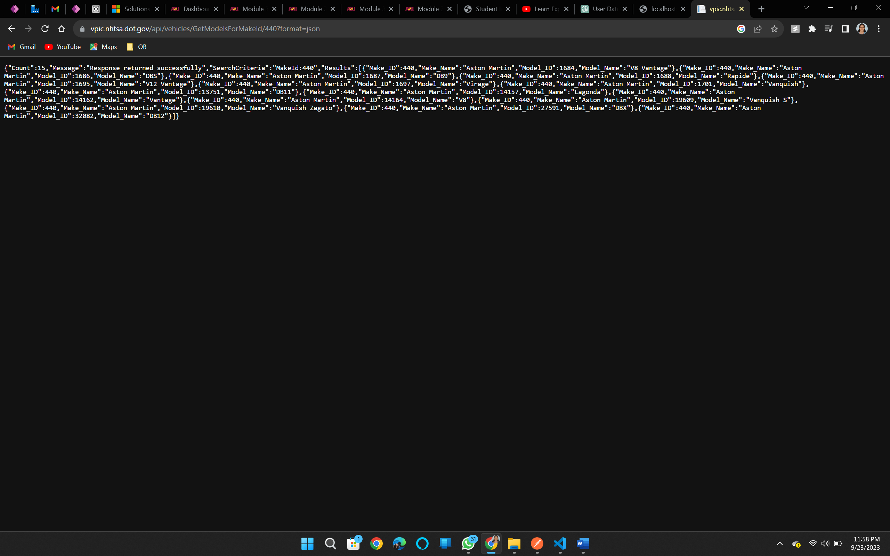

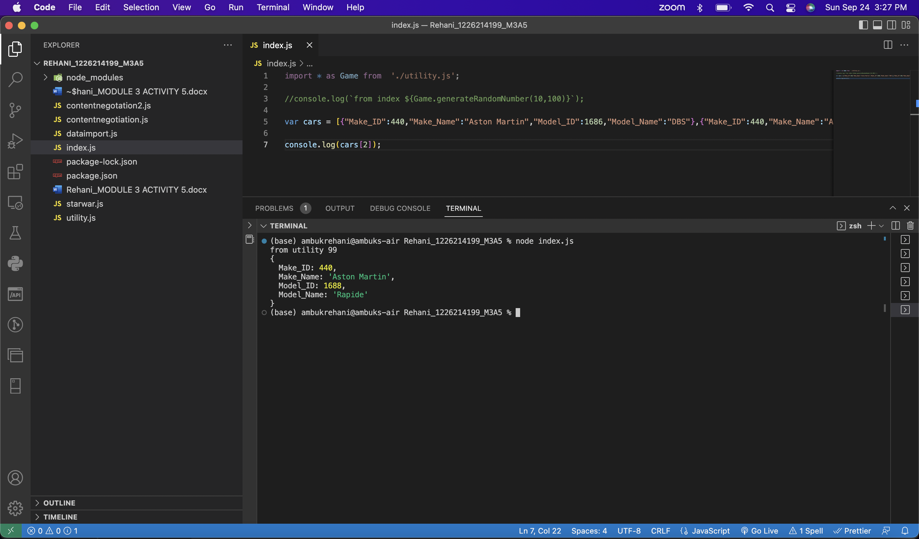

DATA FORMATS AND DATA EXCHANGE:

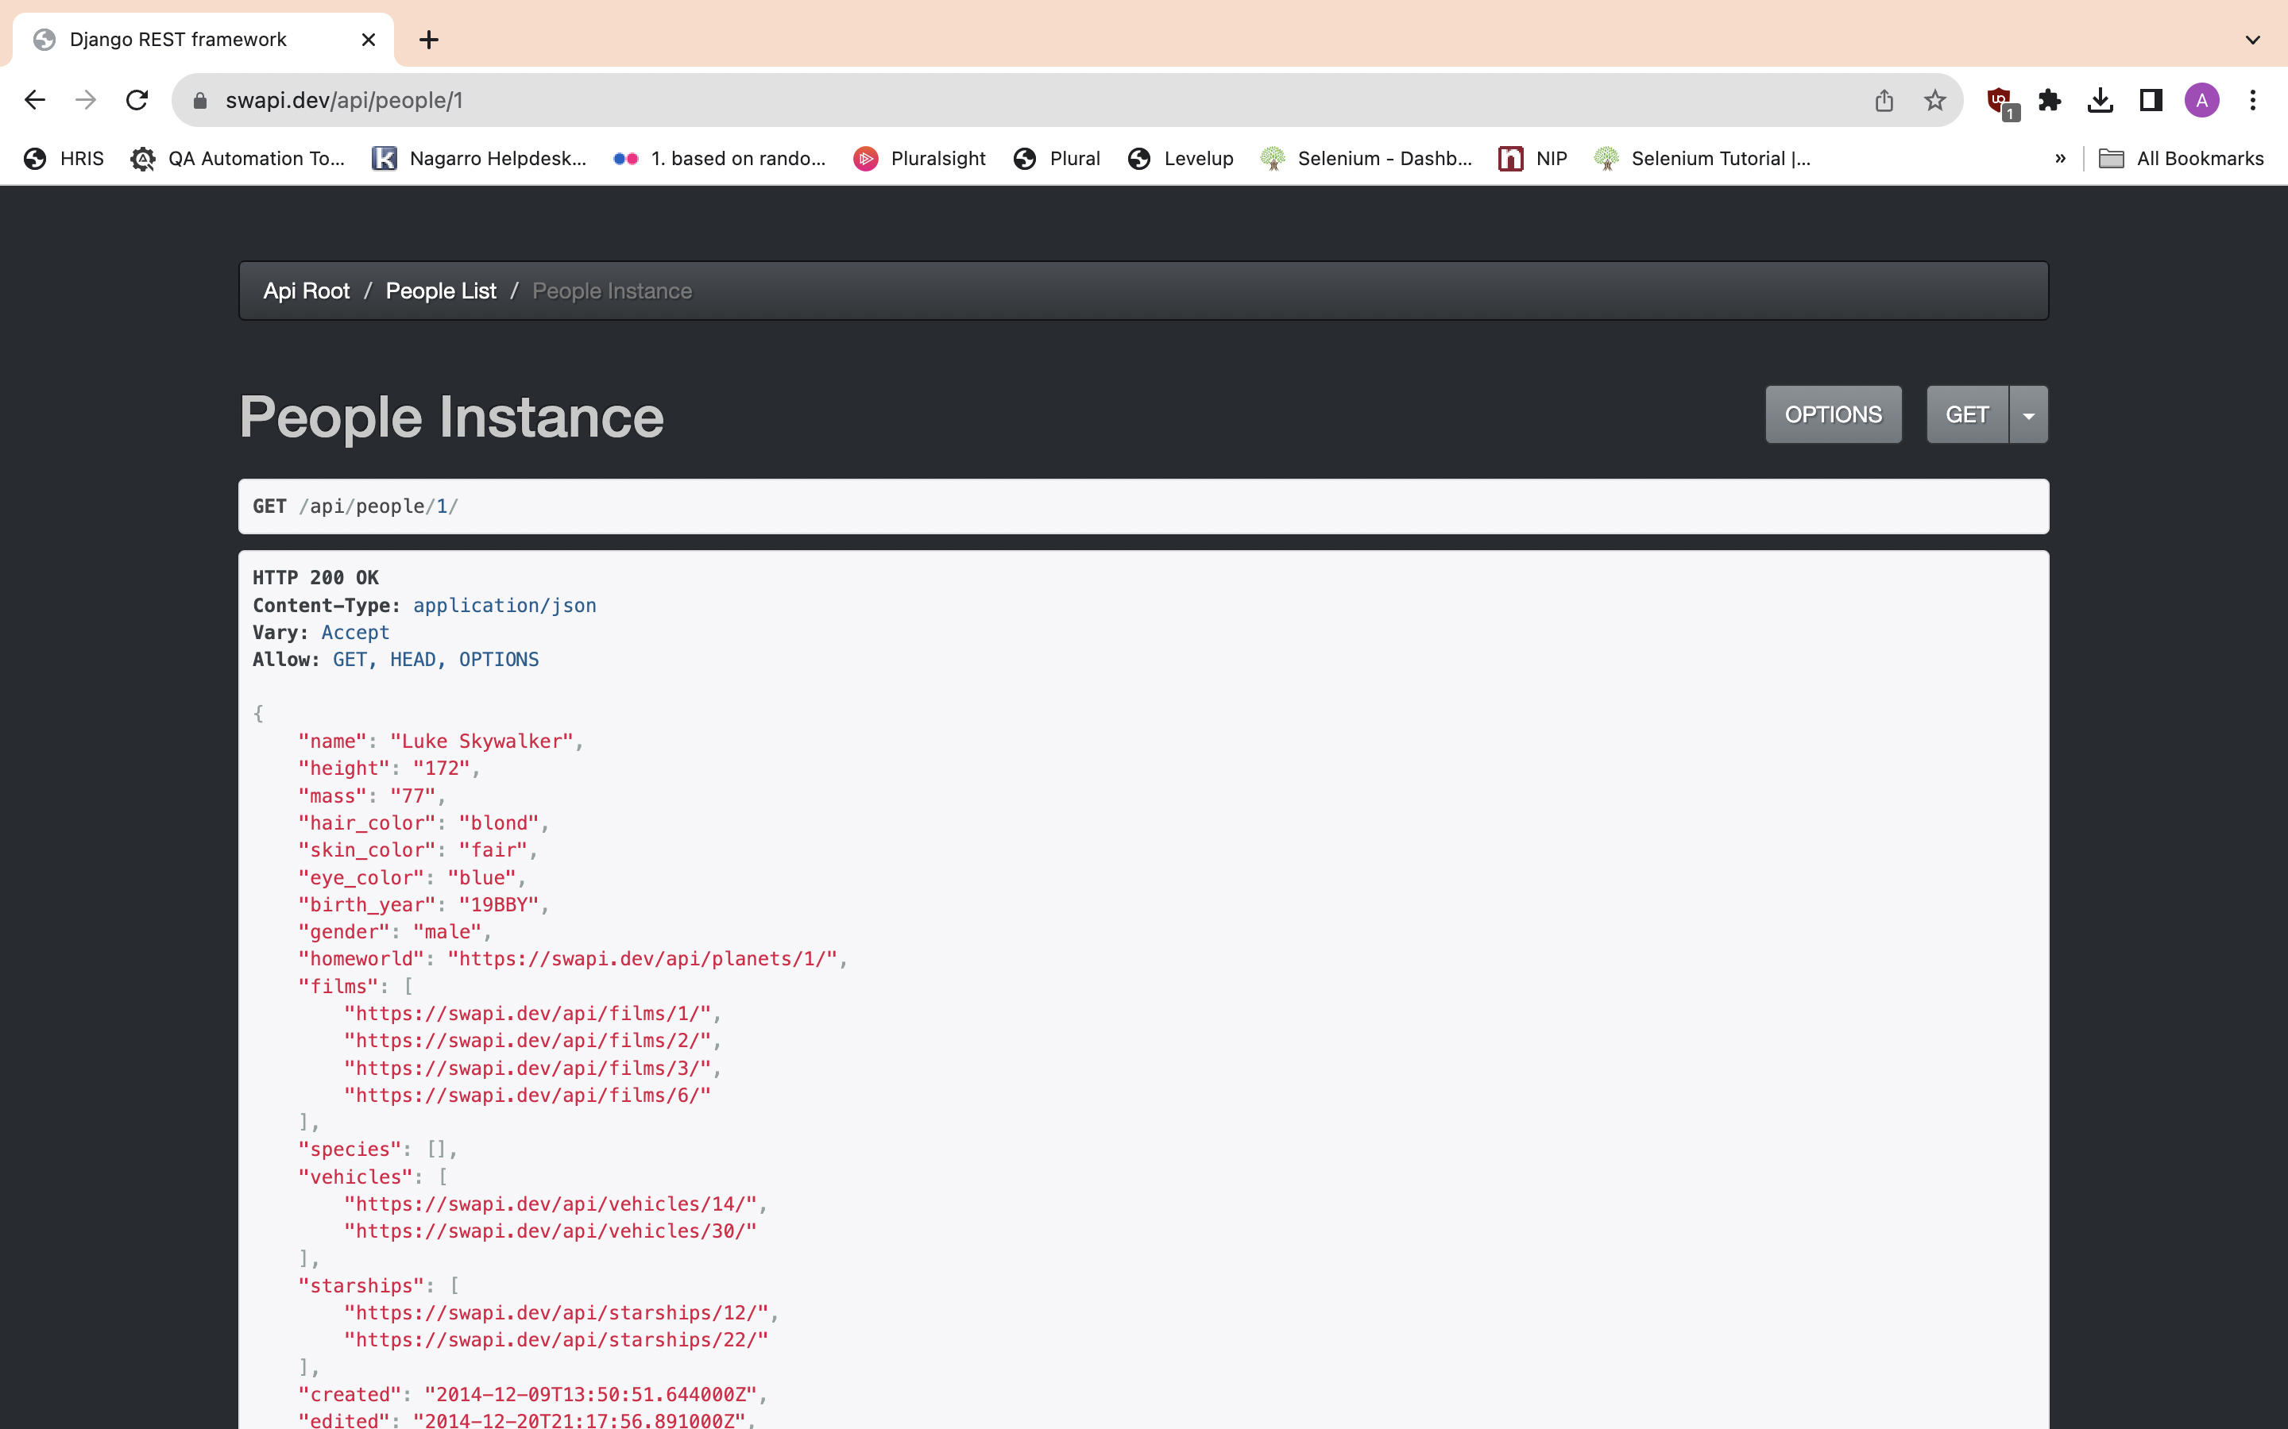

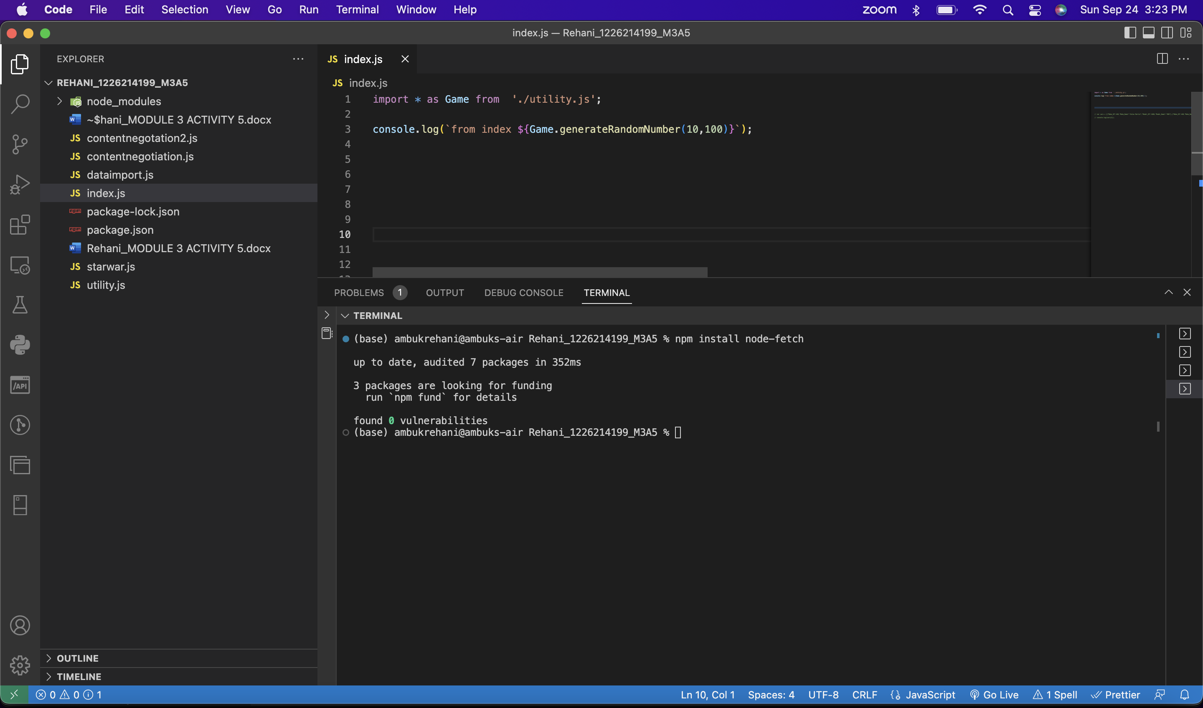

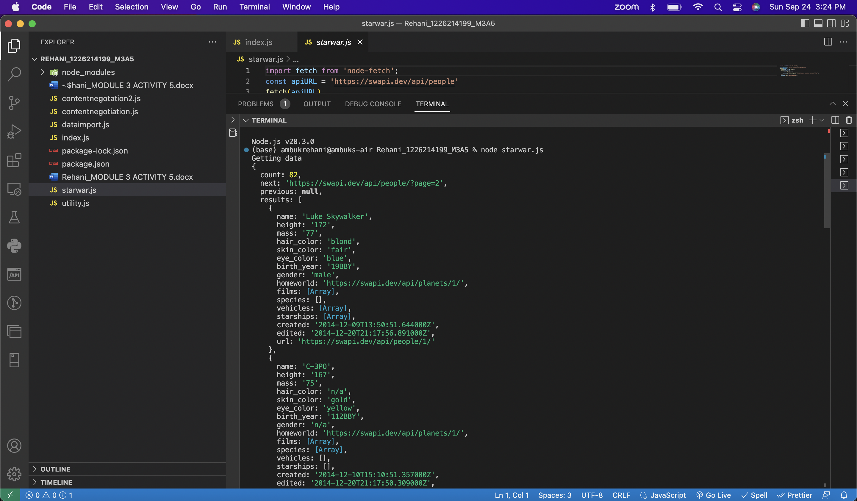

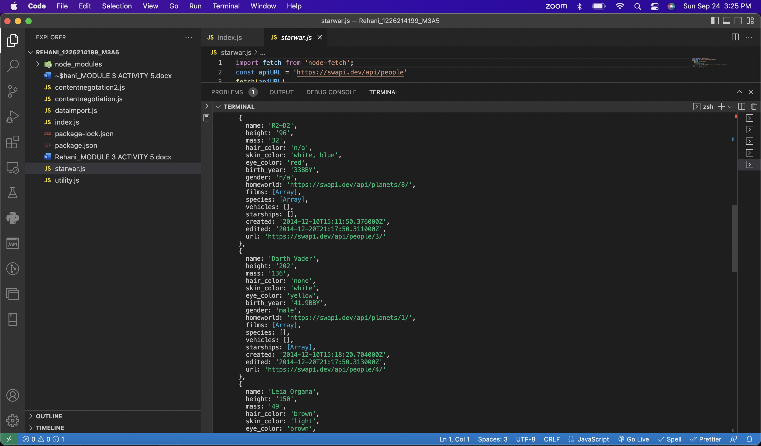

CONTENT NEGOTIATION:

